### [**Hanukkah Star Ornament**](https://papercraftetc.blogspot.com/2019/12/hanukkah-star-ornament.html)

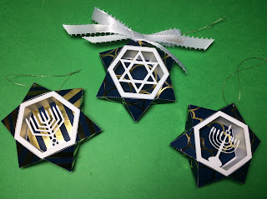

Hanukkah Star Ornament

This Hanukkah Star ornament design is based on the same premise as Twelve Days of Christmas Ornaments. Please use the instructions from my previous blog posting to make this ornament. <https://papercraftetc.blogspot.com/2019/12/the-twelve-days-of-christmas.html>

Happy Hanukkah to all of my Jewish friends!